Software Design Document
<Laravel based job portal web application>


By
Suleman Imran
S25BINFT7M04036
Session Spring 2025 – 2027

Supervisor
Dr. Omer Riaz

Department of Information Technology

Faculty of Computing

The Islamia University Of Bahawalpur

Summary

A job portal is an online platform designed to connect job seekers with employers by offering a centralized space for job listings and applications. It simplifies the recruitment process through features like resume uploads, job search filters, automated job alerts, application tracking, and company profiles. For employers, it provides tools to post vacancies, screen candidates, and manage recruitment efficiently. For job seekers, it offers access to diverse employment opportunities, personalized job recommendations, and career development resources.

The purpose of a job portal is to bridge the gap between employers and candidates, making the hiring process more efficient, accessible, and strategic.

The scope of a job portal includes:
1. Broad job listing access across industries.
2. Easy resume upload and management.
3. Automated job alerts tailored to user preferences.
4. Application tracking systems.
5. Insightful company profiles.
6. Networking features to connect with professionals.

Overall, job portals play a vital role in the modern job market by digitizing and optimizing the job search and hiring process.

Table of Contents

Application Architecture 3
UML diagram 4
Data Model Schema 5
User Interface 7
Sequence diagram 12
ER-diagram 13

- Application Architecture

The Job Portal Web Application is designed using the Model-View-Controller (MVC) architectural pattern, implemented using PHP for backend logic through the Laravel framework, and HTML, CSS, and JavaScript for the frontend. React may optionally be used to enhance interactivity on certain views. The system allows users to create accounts, post or apply for jobs, manage profiles, communicate via messaging, and leave feedback. This architecture ensures the application remains modular, scalable, and easy to maintain.

MVC (Model-View-Controller)

Model:
Handles the business logic and communication with the MySQL database using Laravel’s Eloquent ORM. Models define the structure and relationships of data entities such as:
- User (Job seeker / Employer)
- Job
- Application
- Company
- Message
- Feedback

View:
The front-end of the application is developed using HTML, CSS, and JavaScript. Views are created using Laravel Blade templates to present data and capture user input. (React can be optionally used for dynamic UI interactions.)
Key Views:
- Homepage
- Job Listing Page
- Job Detail Page
- Login / Register Page
- User Dashboard (Job seeker & Employer)
- Application Status Page

Controller:
Controllers act as an intermediary between Models and Views. They handle incoming HTTP requests, invoke models, apply logic, and return appropriate responses or view

Controller Responsibilities
- Show all job listings
- Show job detail
- Post a job (for employers)
- Apply to a job (for candidates)
- View user applications

UML Diagram:

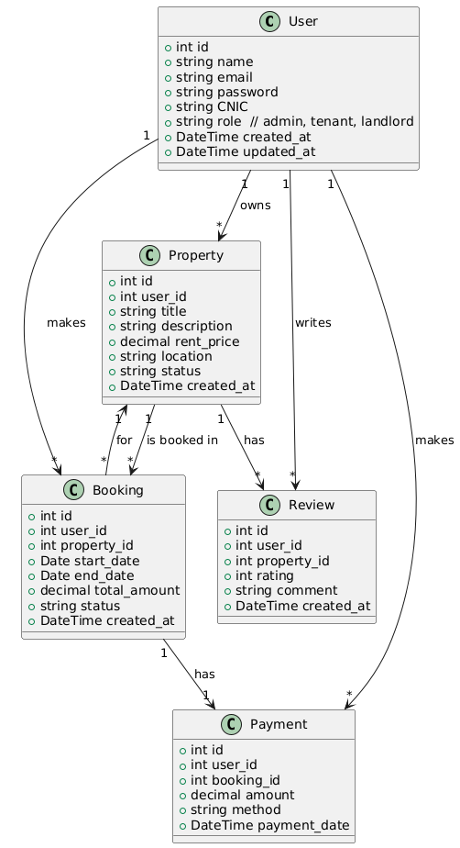
- Data Model Schema

User
- id: INT (Primary Key)
- name: VARCHAR
- email: VARCHAR (Unique)
- password: VARCHAR (Encrypted)
- role: ENUM (job_seeker, employer, admin)
- created_at, updated_at: TIMESTAMP
Entity Relationships
- User ↔ Job: One-to-many (An employer can post multiple jobs)
- User ↔ Application: One-to-many (A job seeker can apply to many jobs)
- User ↔ Message: One-to-many (Sender/Receiver relationships)
- User ↔ Feedback: One-to-many
- User ↔ Company: One-to-one (Each employer may have one company profile)

Company
- id: INT (PK)
- user_id: INT (FK → User) (Employer)
- name: VARCHAR
- industry: VARCHAR
- description: TEXT
- website: VARCHAR
- created_at, updated_at: TIMESTAMP
Entity Relationships
- Company ↔ Job: One-to-many (Each company can post many jobs)

Job
- id: INT (PK)
- user_id: INT (FK → User) (Posted by Employer)
- company_id: INT (FK → Company)
- title: VARCHAR
- description: TEXT
- location: VARCHAR
- salary: DECIMAL
- type: ENUM (full-time, part-time, remote, etc.)
- deadline: DATE
- created_at, updated_at: TIMESTAMP
Entity Relationships
- Job ↔ Application: One-to-many
- Job ↔ Feedback: One-to-many

Application
- id: INT (PK)
- user_id: INT (FK → User) (Job seeker)
- job_id: INT (FK → Job)
- resume_path: VARCHAR
- status: ENUM (pending, accepted, rejected)
- applied_at: DATETIME
Entity Relationships
- Many-to-One with User
- Many-to-One with Job

Message
- id: INT (PK)
- sender_id: INT (FK → User)
- receiver_id: INT (FK → User)
- message: TEXT
- sent_at: DATETIME
Entity Relationships
- User ↔ User: Many-to-many (via sender_id and receiver_id)

Feedback
- id: INT (PK)
- user_id: INT (FK → User) (Job seeker)
- job_id: INT (FK → Job)
- rating: INT
- comment: TEXT
- created_at: TIMESTAMP
Entity Relationships
- Many-to-One with User
- Many-to-One with Job

- User Interface

Design Niche:
- Clean and professional layout aligned with career/job search industry
- Focus on usability and clarity for quick job browsing and posting
- Card- and table-based UI for job listings, applications, and user profiles

Screen Constraints / Responsiveness:
- Fully responsive design using a mobile-first approach
- Targeted screen sizes:
  - Mobile: ≥ 360px
  - Tablet: ≥ 768px
  - Desktop: ≥ 1280px

List of Screens/Pages and UI Elements

1. Login Page
Purpose: Authenticate users (Job Seeker, Employer, Admin)
UI Element | Type | Description | Input Constraints
Email | Textbox | Registered email | Must be valid email format
Password | Password | User’s password | Min 8 characters
Login Button | Button | Submit login form | Enabled when fields are valid
Forgot Password | Link | Redirect to password reset page

2. Registration Page
Purpose: Allow new user signup
UI Element | Type | Description | Input Constraints
Name | Textbox | Full name | Min 2 characters
Email | Textbox | Unique user email | Must be valid
Password | Password | Secure password | Min 8 characters
Role | Dropdown | Choose role (Job Seeker/Employer) | Required
Register | Button | Submit registration | All fields must be valid

3. Home Page
Purpose: Show latest and featured job listings
UI Element | Type | Description | Input Constraints
Search Bar | Textbox | Keyword or job title | Min 2 characters
Location | Textbox | City/region | Optional
Job Cards | Cards | Title, company, location, type | Auto-filled
View Button | Button | View job details

4. Job Details Page
Purpose: Show full job information and apply
UI Element | Type | Description | Input Constraints
Job Description | Text | Role details, requirements
Company Info | Text | Company name, industry
Apply Button | Button | Opens application form | Disabled if not logged in
Review Section | List | Ratings and comments

5. Application Page
Purpose: Submit job application
UI Element | Type | Description | Input Constraints
Resume Upload | File Input | Upload PDF resume | Must be .pdf, max 5MB
Cover Letter | Textarea | Optional message | Max 500 characters
Submit Button | Button | Apply to job | Enabled after valid resume

6. User Dashboard (Role-Based)

A. Job Seeker Dashboard
Tabs: My Applications, Saved Jobs, Profile, Messages
UI Element | Type | Description | Input Constraints
Application List | Table | Applied jobs and statuses
Cancel Button | Button | Cancel application (if pending) | Only for pending
Edit Profile | Form | Name, email, password, resume | Validation on each field

7. Employer Dashboard
Tabs: My Jobs, Applications, Add Job, Messages
UI Element | Type | Description | Input Constraints
Job List | Table | All jobs posted
Add Job Button | Button | Opens job creation form
View Applications | Button | See who applied
Accept/Reject | Button | Manage applications | Only for pending

8. Admin Panel
Tabs: User Management, Job Moderation, Reports
UI Element | Type | Description | Input Constraints
User Table | Table | View user roles/status
Block/Delete | Button | Manage user access | Requires confirmation
Job Moderation | Table | View, approve or reject jobs

9. Feedback/Rating Page
Purpose: Submit review for a company or job post
UI Element | Type | Description | Input Constraints
Rating Stars | Star | 1 to 5 stars | Required
Comment Box | Textarea | Optional feedback | Max 500 characters
Submit Button | Button | Post feedback | Enabled after rating selected

Sequence diagram:
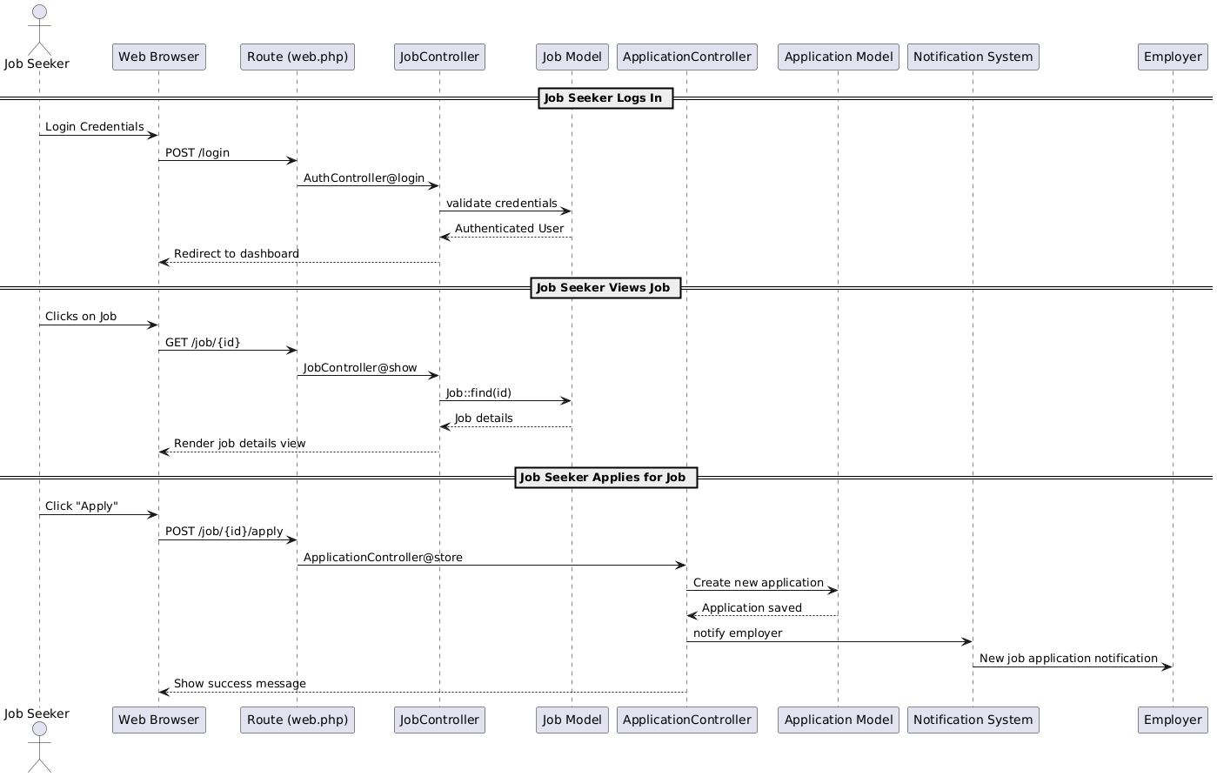

ER-Diagarm

